TITLE: ColdFit: A Multimodal AI Clothing Adaptation Assistant
WORD COUNT: 1497
BGN: 8066D

USE-CASE AND GOALS

International students from warmer climates often find UK winters uncomfortable, and differing dress norms can make clothing decisions feel socially risky. Weather forecasts are presented as numbers rather than bodily sensations, so understanding “cold” often depends on embodied experience (Stewart & Bolton, 2023). I designed ColdFit, a multimodal AI clothing assistant that provides text guidance paired with visual outfit examples for temperatures of 12°C and below. The design is grounded in UK cold-health guidance, UK winter conditions, and thermal comfort and clothing insulation concepts (UKHSA & Met Office, 2023; ASHRAE 55; ISO 9920 ColdFit’s primary goal is to assist and empower users to make quick, confident, climate-appropriate clothing decisions by translating abstract weather information into actionable outfit guidance.

Stakeholders include international students from warmer climates, university wellbeing services, and researchers requiring controlled evaluation.

SYSTEM DESIGN AND IMPLEMENTATION
ColdFit’s design was informed by human-centred AI principles emphasising reliability, transparency, and safety, alongside Value Sensitive Design as a method for translating stakeholder concerns into interaction requirements (Shneiderman, 2020; Friedman et al., 2002; van de Poel, 2013).
I spoke to three international students from warmer climates and reflected on my own experience adjusting to UK winters.

These conversations highlighted four concerns:
• V1 Autonomy: preference for guidance that supports choice rather than prescribing one outfit.
• V2 Clarity: difficulty interpreting temperature values in practical terms.
• V3 Confidence: anxiety about appearing underdressed.
• V4 Adaptability: uncertainty about balancing outdoor warmth with indoor comfort.

These values informed four design implications:
• D1 Scoped autonomy: recommendations are framed as suggestions rather than commands.
• D2 Transparency: explanations are provided for why layers are recommended.
• D3 Safety boundaries: guidance is restricted to general advice within validated temperature bands.
• D4 Dual output modality: text reasoning is paired with visual outfit examples (Entwistle, 2000/2001; Mayer, 2009).

ColdFit used a hybrid prototyping approach:
• a Figma interactive prototype for the guided condition; and
• a Wizard-of-Oz web prototype (Netlify + Firebase backend) for chat-based interaction and controlled response delivery.

Across conditions, the system supports text interaction and visual output. For each temperature band, ColdFit recommends two layering strategies:
• Outdoor-Optimised: prioritising insulation and protection.
• Indoor-Optimised: prioritising removability and breathability.
These options reflect ensemble layering principles (ASHRAE 55; ISO 9920 A user persona (Alyssa, an international student from Malaysia unfamiliar with UK cold) and an AI persona (supportive and non-judgemental) guided tone and framing. (Appendices A and B).

RESEARCH QUESTIONS, EVALUATION METHODS AND METRICS

Design Configuration
ColdFit varies two interface factors in a 2×2 mixed design:
- IV1 Interaction style (free chat vs guided chat, between-subjects), testing the trade-off between user control and structured support in how initiative is shared. (Horvitz, 1999)
- IV2 Output presentation (text-dominant vs image-dominant, within-subjects, counterbalanced), testing whether emphasis on verbal explanation versus visual examples changes confidence and perceived usefulness. (Mayer, 2009)
This yields four configurations:
- Free Chat × Text
- Free Chat × Image
- Guided Chat × Text
- Guided Chat × Image
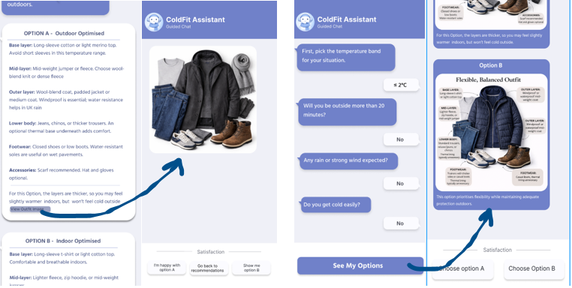
Figure 1: Guided-chat condition in ColdFit, showing the structured context questions and the two output variants: text-first and image-with-labels.

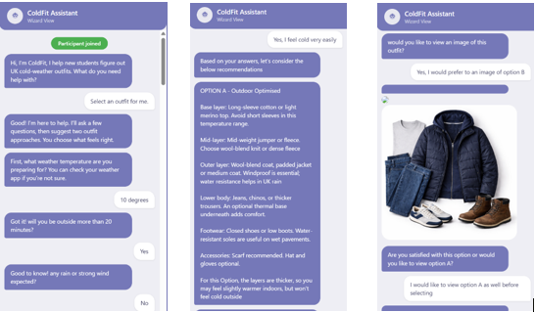
Figure 2: Free-chat condition in ColdFit, showing conversational context collection, text-first recommendations, and the follow-up image view shown only after the user requests

Research Questions
The study addressed three research questions:
- RQ1: How does interaction style (free chat vs guided chat) affect perceived autonomy and cognitive effort?
- RQ2: How does output presentation (text-dominant vs image-dominant) affect decision confidence and perceived usefulness?
- RQ3: What value tensions and unintended risks emerge when users interact with an AI clothing recommendation system?

Study Design
I recruited 8 international students from warmer climates, studying at Cambridge University and Anglia Ruskin University, through word-of-mouth. They were randomly assigned to free chat or guided chat (4 per condition).
Each participant completed two clothing decision tasks (one per output condition, counterbalanced). They imagined a UK cold-weather situation, entered a temperature of 12°C or below, answered context questions (time outdoors, wind/rain, cold sensitivity), and chose between Outdoor-Optimised and Indoor-Optimised options. Participants thought aloud, completed a post-task survey after each task, and finished with the System Usability Scale and a semi-structured interview.
Sessions lasted 15–25 minutes. Survey items are in Appendix C, interview questions in Appendix D.

Evaluation Methods and Metrics

Table 1: Summary of evaluation methods, measures, scales, timing, and their alignment with the research questions.
Method | Measure(s) | Scale / analysis | Timing | RQ
Post-task survey | Autonomy (2), cognitive effort (2), confidence, information sufficiency, clarity, trade-off transparency, ease of choice, real-life reliance | 7-point Likert except effort 0–20; descriptive statistics | After each task | RQ1, RQ2
Time-to-decision | Seconds from first system message to confirmed choice | Screen-recording timestamps; descriptive statistics | During each task | RQ1, RQ2
SUS | 10 SUS items | Standard 0–100 scoring | End of session | Overall usability
Think-aloud protocol | Real-time comments on control, hesitation, confusion, trust, comparison behaviour | Qualitative notes / thematic analysis | During each task | RQ1, RQ2, RQ3
Semi-structured interview | Control, trust, risk, modality experience | Reflexive thematic analysis | End of session | RQ3
Note. Autonomy items were adapted from Self-Determination Theory autonomy satisfaction phrasing (Deci & Ryan, 2000). Cognitive effort items were adapted from NASA-TLX (Hart & Staveland, 1988). Information sufficiency/usefulness draws on the usefulness construct from the Technology Acceptance Model (Davis, 1989). SUS scoring follows Brooke (1996).
Data analysis included descriptive stats (given the small N) plus reflexive thematic analysis (Braun and Clarke, 2012) of the think-aloud comments and interview answers.

Table 2: Descriptive summary of mean scores by interaction style and output presentation across the main evaluation measures.
Measure | Free Chat | Guided Chat | Text-before-Image | Image-with-labels
Autonomy | 5.19 | 4.69
Cognitive effort | 5.44/20 | 4.94/20
SUS | 80.0 | 90.0
Decision confidence |  |  | 6.25 | 5.38
Information sufficiency |  |  | 6.00 | 5.75
Clarity |  |  | 5.62 | 5.62
Trade-off transparency |  |  | 6.00 | 5.75
Ease of choice |  |  | 5.00 | 5.33
Real-life reliance |  |  | 5.62 | 5.62

RESULTS
RQ1 (autonomy/efficiency): Free chat scored higher on perceived autonomy, while guided chat scored lower on effort and higher on usability (Table 2). Guided sessions lasted 2–3 minutes versus 6–10 for free chat. Free-chat participants described feeling in control but took longer to phrase requests; guided participants found the system clear and easy, though two said the button flow felt preset. This suggests a modest autonomy–efficiency trade-off: structured prompts reduced friction, while free typing supported agency but increased formulation effort.
RQ2 (confidence/usefulness): Text-first output scored higher on decision confidence, information sufficiency, and trade-off transparency, while clarity and reliance were similar across formats (Table 2). Several participants said text-first helped them understand why options differed. Four preferred the image-led version, describing it as clearer and faster; labelled images reduced the burden of mapping descriptions to outfits. Text-first better supported reflective reasoning, whereas image-with-labels better supported rapid choice and perceptual grounding.
RQ3 (themes on values/risks): Three themes emerged from think-aloud notes and interviews. First, efficiency versus agency: guided chat was faster, while free chat gave more control but required more interaction work. Second, reasoning versus visual reassurance: some preferred text for understanding trade-offs; others found labelled images more concrete. Notably, 7 of 8 linked trust to seeing the image. Third, appropriate reliance: participants said they would use ColdFit in real life but wanted more options, tailoring, or the ability to swap items with what they owned.

DISCUSSION
These findings align with human-centred AI guidance on user control and transparency (Shneiderman, 2020). The autonomy–efficiency trade-off reflects mixed-initiative design research, where system-initiated structure reduces effort, but limits perceived control (Horvitz, 1999). Differences between output modalities suggest multimodal coordination matters (Mayer, 2009). A Value Sensitive Design lens helps explain the tension between visual reassurance and normative influence, since outfit examples can support confidence while embedding assumptions about appropriate dress (Friedman et al., 2002).

Value trade-offs:
- Autonomy versus efficiency: free chat preserved control but increased formulation effort; guided chat reduced friction but felt constrained to some.
- Reasoning versus immediacy: text-first supported understanding of trade-offs; image-with-labels reduced the burden of translating descriptions into outfits.
- Reassurance versus normative fit: images increased trust, but fixed outfits may imply narrow assumptions about appropriate dressing.

Unintended risks and mitigations:
- Over-reliance: users may substitute ColdFit for personal judgement. Mitigation: frame outputs as suggestions.
- Normative visual assumptions: outfit images may imply a single standard of acceptable dressing. Mitigation: use more diverse, swappable visuals.
- Accessibility exclusion: text-heavy output may disadvantage some users, while image-led output may disadvantage others. Mitigation: retain dual-modality support and simplify wording.
Limitations and future work:
ColdFit was evaluated with a sample in a short study, so findings should be treated as formative rather than generalisable. The hybrid prototype and Wizard-of-Oz setup supported controlled comparison but may have affected perceived naturalness. Future work should test ColdFit in longer-term use, integrate live weather data, explore a hybrid guided-plus-free-text interaction, and refine cultural visual representations.

CONCLUSION
ColdFit shows that multimodal AI can support cold-weather clothing decisions for international students, but the benefit depends on how interaction structure and modality emphasis are coordinated. Guided chat improved usability, text-first output strengthened confidence, and images added reassurance and ease of choice. The project contributes design evidence for multimodal AI decision-support and shows that low-stakes recommendation systems involve trade-offs in autonomy, clarity, confidence, and inclusion.

REFERENCES
ASHRAE. (2020). ANSI/ASHRAE Standard 55-2020: Thermal Environmental Conditions for Human Occupancy. American Society of Heating, Refrigerating and Air-Conditioning Engineers.
Braun, V. & Clarke, V. (2006). Using thematic analysis in psychology. Qualitative Research in Psychology, 3(2), 77–101.
Brooke, J. (1996). SUS: A "quick and dirty" usability scale. In P.W. Jordan, B. Thomas, B.A. Weerdmeester, & I.L. McClelland (Eds.), Usability Evaluation in Industry (pp. 189–194). Taylor & Francis.
Davis, F.D. (1989). Perceived usefulness, perceived ease of use, and user acceptance of information technology. MIS Quarterly, 13(3), 319–340.
Deci, E.L. & Ryan, R.M. (2000). The "what" and "why" of goal pursuits: Human needs and the self-determination of behavior. Psychological Inquiry, 11(4), 227–268.
Entwistle, J. (2000). The Fashioned Body: Fashion, Dress and Modern Social Theory. Polity Press.
Friedman, B., Kahn, P.H., & Borning, A. (2002). Value Sensitive Design: Theory and Methods. UW CSE Technical Report 02-12-01, University of Washington.
Hart, S.G. & Staveland, L.E. (1988). Development of NASA-TLX (Task Load Index): Results of empirical and theoretical research. In P.A. Hancock & N. Meshkati (Eds.), Human Mental Workload (pp. 139–183). North-Holland.
Horvitz, E. (1999). Principles of mixed-initiative user interfaces. In Proceedings of the SIGCHI Conference on Human Factors in Computing Systems (CHI '99) (pp. 159–166). ACM.
ISO. (2007). ISO 9920: Ergonomics of the thermal environment — Estimation of thermal insulation and water vapour resistance of a clothing ensemble. International Organization for Standardization.
Mayer, R.E. (2009). Multimedia Learning (2nd ed.). Cambridge University Press.
Shneiderman, B. (2020). Human-centered artificial intelligence: Reliable, safe & trustworthy. International Journal of Human–Computer Interaction, 36(6), 495–504.
Stewart, A. & Bolton, M. (2023). Cold comfort: Adapting thermal perception across climatic contexts. Journal of Environmental Psychology, 86, 101946.
UKHSA & Met Office. (2023). Cold Weather Plan for England. UK Health Security Agency.
van de Poel, I. (2013). Translating values into design requirements. In D.P. Michelfelder, N. McCarthy, & D.E. Goldberg (Eds.), Philosophy and Engineering: Reflections on Practice, Principles and Process (pp. 253–266). Springer.

